**Chapter 6 Making Comments Precise and Compact**

* Write comments as specific and detailed as possible.
* Because comments consumes extra space on the screen and more time to read, therefore, comments should be compact.

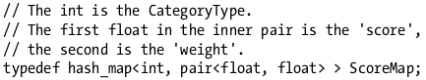

* The better way is:



* Avoid ambiguous pronouns
* Pronouns can make things confusing.



* ‘it’ might refer to the data or the cache. The safest thing is to ‘fill in; pronouns if there’s any chance of confusion.





* Polish Sloppy Sentences



After improving:



* Describe functions behavior precisely.



* Use input/output examples that illustrate corner cases
* Good Example:



* State the intent of code instead of what the code does. A good example:



* Comments may also be a redundancy check just in case the comment doesn’t match with the code.
* In languages like Phyton, you can assign the arguments by name; example:

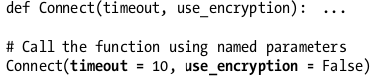

* In java, you can use an inline comment to the same effect:



* Use information-dense words; There are specific words or phrases that have been developed to describe pattern/idioms, this makes comments more compact.

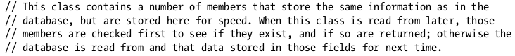

A more compact comment:

